Winger Incident / Near Miss Reporting Form

_____ Near Miss _____ Property Damage
_____ First Aid _____ Medical Aid _____ OSHA Recordable _____ LOST TIME

Date of Incident: ______________ Day of Week: (Please Circle) Sun Mon Tue Wed Thu Fri Sat
Time of Incident: _______AM/PM Time Shift Started: __________AM/PM Overtime: _____ Yes _____ No
Date Reported: _______________ Safety Director Notified? ____ Yes ____ No
If Date Is Different, Reason Report Delayed: ____________________________________________________________________
Location of Incident/Customer Name: _________________________________________________________________________
County/City/State/Zip: _____________________________________________________________________________________
Project Name: _____________________________________________________________ Area/Floor: _____________________
Manager/Supervisor: _______________________________________ Foreman: _______________________________________
Employee Full Printed Name: ________________________________________________________________________________ First Middle Last
Address: _________________________________________________________________________________________________
Street Address City State Zip
Phone Number: _____________________________ Location Regularly Worked: ______________________________________
Occupation: ______________________________ Skill Level: ___________________________ Union: _____________________
Start Date: _________________ Sex: ___ Male ___ Female Age: ____ $__________ Wage __ Hourly__ Salary
Property Damaged: ________________________________________________________________________________________
Lost Production / Estimated Value: ____________________________________________________________________________
Date of Previous Incidents for this Person: ______________________________________________________________________
Drug/Alcohol Test Taken: _____ Yes _____ N/A PJHA for job completed? ____ Yes ____ No (Please attach)
Mobile Equipment Pre-Use Checklist Permits Completed? ____ Yes ____ N/A (Please attach)
Permits Completed? ____ Yes ____ N/A (Please attach if possible)
Were Photos Taken if Allowed? _____ Yes_____ No (Please attach) Did an EAP take place? _____ Yes _____ N/A
If this was a vehicle accident, was there a Police Report filed? _____ Yes _____ N/A
Did you fill out an Iowa DOT Accident Form? _____ Yes_____ No (Please attach)
Insurance Notified _____ Yes _____ N/A
Witness Printed Name: ____________________________________________ Witness Phone Number: ___________________
Witness Statement:

INJURED EMPLOYEE SECTION:
Was the Employee Injured? _____ Yes _____ No (move on to next page)
Does family need to be notified: _____ Yes _____ N/A
Regular Employee: ____ Full Time ___ Part Time Marital Status: ___ Unmarried ____ Married ____ Separated
Full Wages Paid for Date of Incident or Injury: _____ Yes _____ N/A
Normal Hours/Days Worked Per Week: (40 hrs Mon-Fri, 40 hrs Mon-Thu, etc.) ________________________________________
Tax Filing Status: ____Single ____ Single/Head of Household ____Married/Filing Joint ____Married/Filing Separate
Educational Level: ___GED ___Graduated HS ___College ___ Yrs
Employee’ Authorization to Release Medical Records to Insurance? ____ Yes ____ No
OSHA Log Updated or OSHA Notification Required? _____ Yes _____ N/A (800-321-6742)

What part of the body was injured (state left or right arm, leg, etc.) / Check nature of the injury:
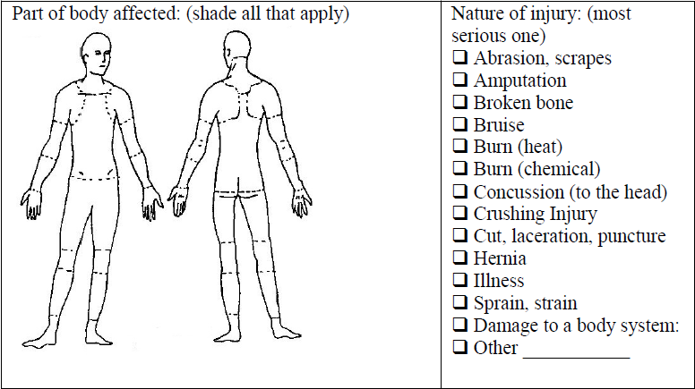
Name the object that directly injured the employee:
Was he driven to a clinic by a Winger employee?

DESCRIPTION: In detail describe the incident, step by step and answer these questions; Who, What, When, How, Why? What was the job task, who was working, what the affected employee was doing just before, was there anyone else involved, PPE worn, any weather factors: (If necessary, continue on the back or another piece of paper.)

ROOT CAUSE: Why it happened? What could have been done differently? Was the employee in Skill, Rule, or Knowledge Based mode? What were the error traps?

PREVENTION / LESSONS LEARNED: What can we do different in the future to prevent this from happening again?

ACTION ITEMS: RESPONSIBLE PERSON: DUE DATE:
:
Review incident with ALL Winger employees Jerelyn Merrill, Safety Director

Incident Response Team:

Investigated By: _________________________________________________________________ Date: _____________________

Investigated By: _________________________________________________________________ Date: _____________________

Reviewed By: ___________________________________________________________________ Date: _____________________

Employee Signature: ______________________________________________________________ Date: _____________________

